Assignment 2
Task 1: Data Preparation & Transformation
Do the following:
- Assign proper variable types
- Add labels & value labels
- Create a new variable:
👉 Performance Level (based on CGPA)
  - CGPA ≥ 3.50 → High
  - CGPA < 3.50 → Low
- Create another variable:
👉 Study Category
  - Study Hours ≥ 5 → High Study
  - Study Hours < 5 → Low Study
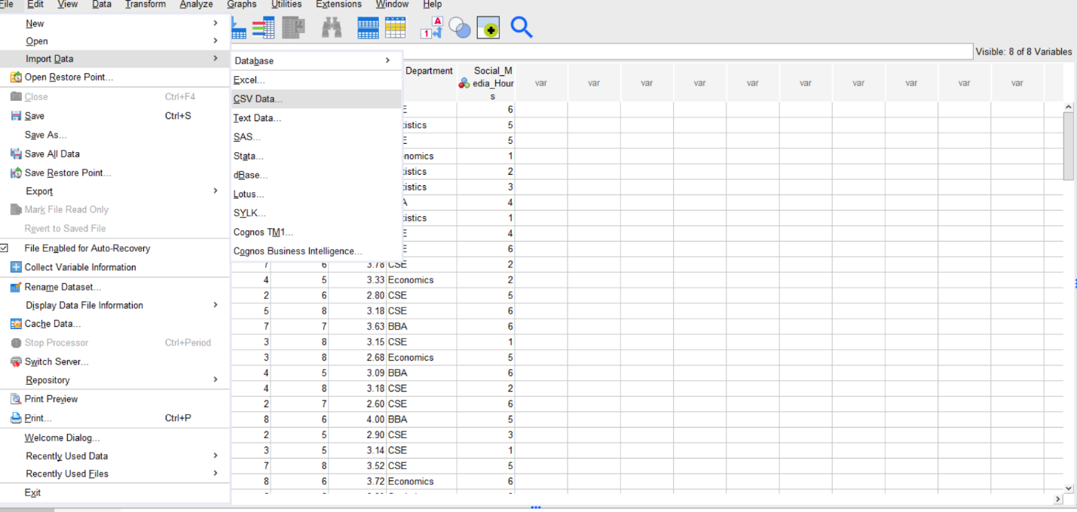
Import Data From CSV:

Add Levels:
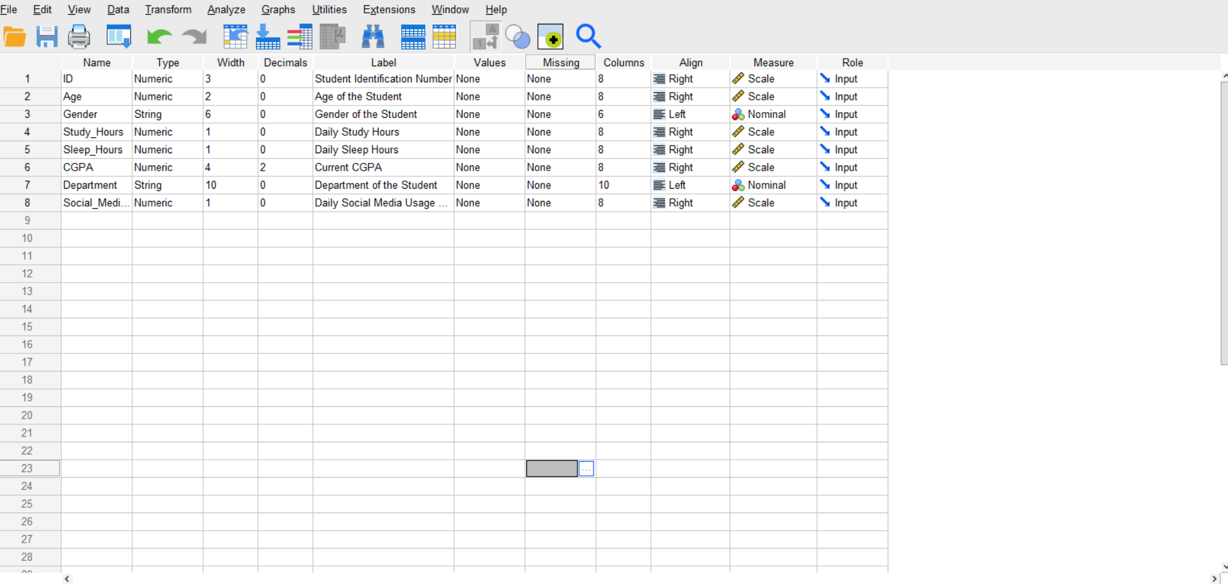
Create New Variable:
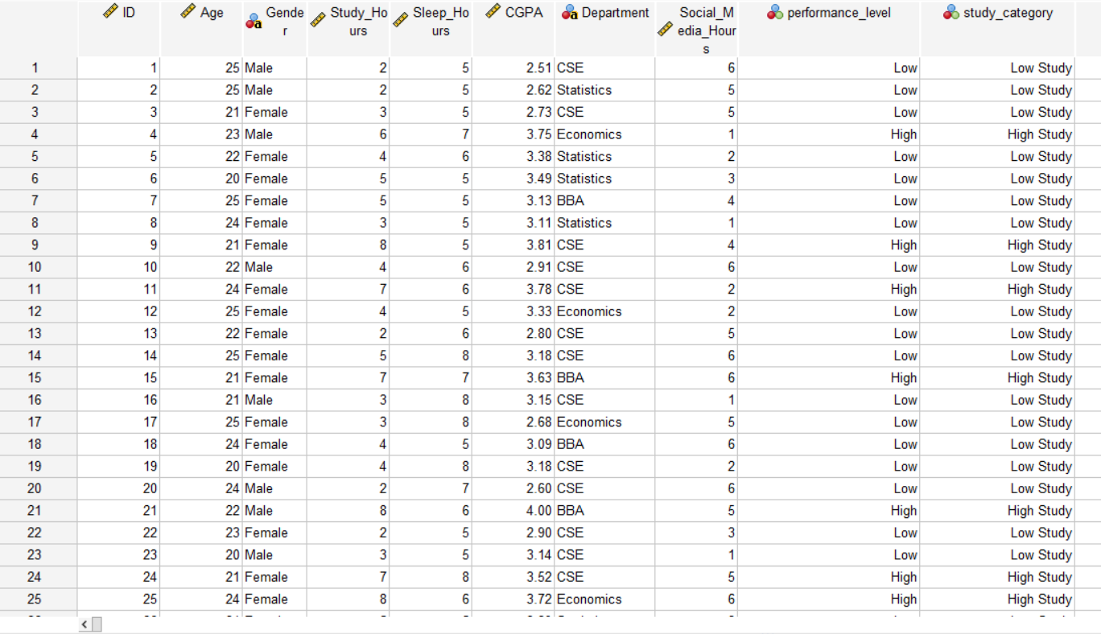
performance_level variable was created from CGPA to classify students based on academic performance, while study_category was created from study hours to categorize students according to their study habits.

🔹 Task 2: Cross-tabulation & Categorical Analysis
- Create Cross-tab:
👉 Gender vs Performance Level
- Add:
✔ Row % / Column %
📌 Write 2–3 lines:
- Which group performs better?
Cross-tab:
Gender of the Student * performance_level Crosstabulation
 |  |  | performance_level |  | Total
 |  |  | Low | High
Gender of the Student | Female | Count | 36 | 16 | 52
 |  | % within Gender of the Student | 69.2% | 30.8% | 100.0%
 |  | % within performance_level | 59.0% | 41.0% | 52.0%
 | Male | Count | 25 | 23 | 48
 |  | % within Gender of the Student | 52.1% | 47.9% | 100.0%
 |  | % within performance_level | 41.0% | 59.0% | 48.0%
Total |  | Count | 61 | 39 | 100
 |  | % within Gender of the Student | 61.0% | 39.0% | 100.0%
 |  | % within performance_level | 100.0% | 100.0% | 100.0%

Interpretation
The cross-tabulation shows that male students performed better compared to female students. Among male students, 47.9% were in the high performance category, whereas only 30.8% of female students achieved high performance. Female students had a higher percentage in the low performance category (69.2%) compared to males (52.1%).

🔹 Task 3: Graphs & Visualization
Create:
- Bar Chart → Department-wise student count
- Pie Chart → Gender distribution
- Histogram → CGPA
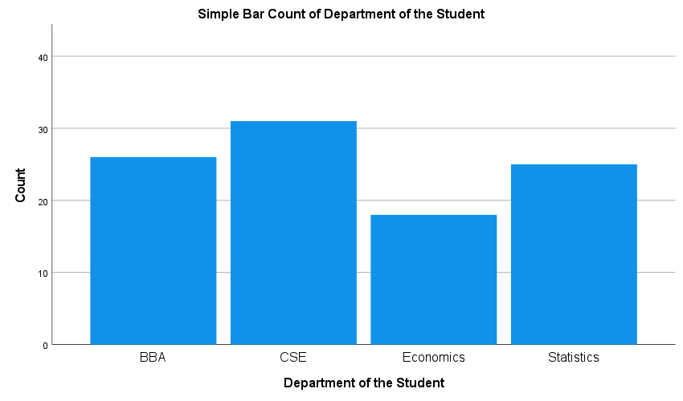
- Boxplot → Detect outliers in CGPA

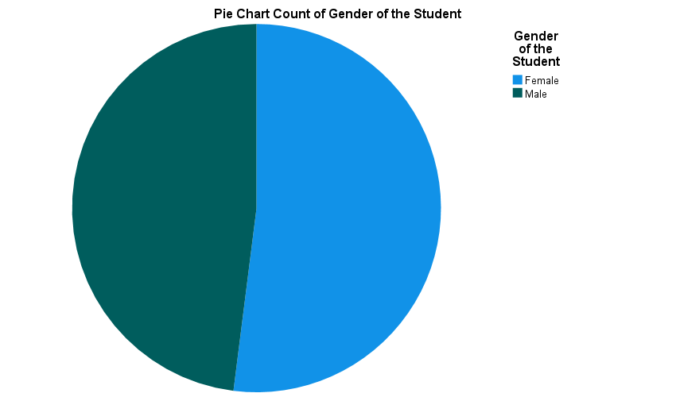
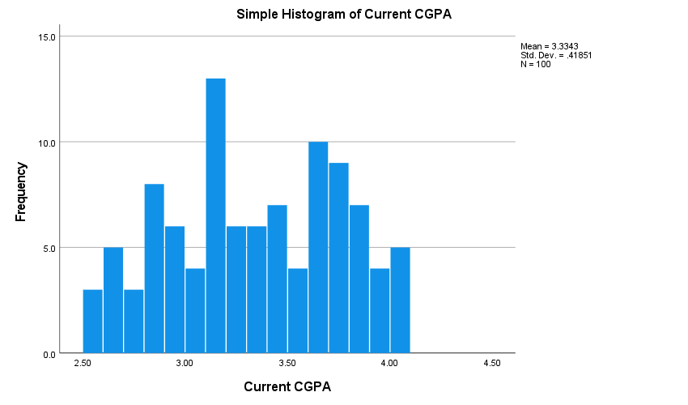
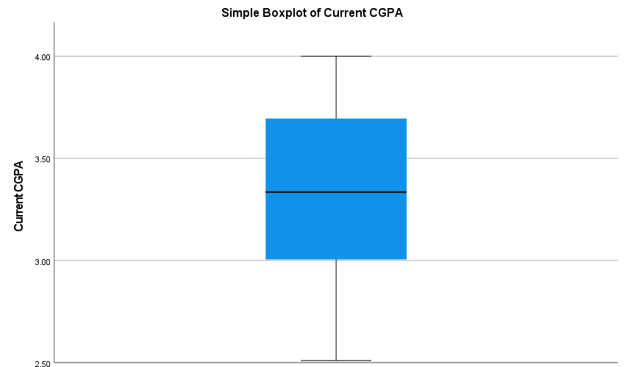
Interpretation
The bar chart shows that the CSE department has the highest number of students, while the Economics department has the lowest student count. BBA and Statistics departments have almost similar numbers of students.
The pie chart indicates that the gender distribution is nearly balanced, although female students are slightly higher in number than male students.
The histogram of CGPA shows that most students’ CGPA values are concentrated between 3.0 and 3.8, indicating a moderate to good academic performance overall.
The boxplot suggests that there are no significant outliers in CGPA, and the CGPA values are fairly evenly distributed around the median.

🔹 Task 4: Explore Function & Normality (10 Marks)
Run Explore for CGPA:
Check:
✔ Normality (Histogram / Shapiro-Wilk)
✔ Outliers
📌 Answer:
- Is the data normally distributed?
- Are there any outliers?
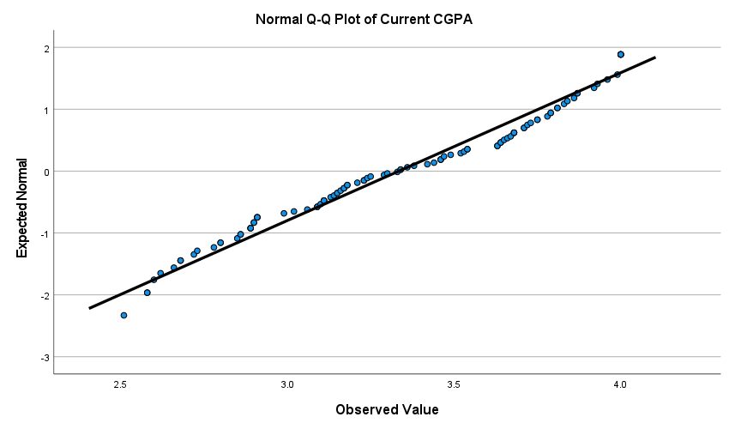

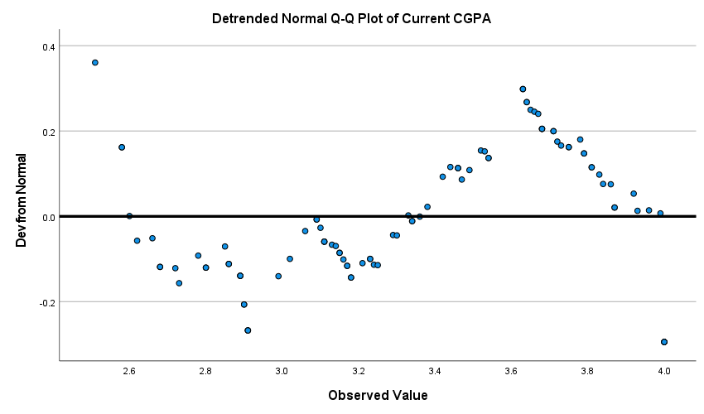

🔹 Task 5: Correlation Analysis
Find correlation between:
- Study_Hours & CGPA
- Social_Media_Hours & CGPA
📌 Answer:
- Positive or negative relationship?
- Strong or weak?

Correlations
 |  | Daily Study Hours | Current CGPA | Daily Social Media Usage Hours
Daily Study Hours | Pearson Correlation | 1 | .929** | -.027
 | Sig. (2-tailed) |  | .000 | .787
 | N | 100 | 100 | 100
Current CGPA | Pearson Correlation | .929** | 1 | -.273**
 | Sig. (2-tailed) | .000 |  | .006
 | N | 100 | 100 | 100
Daily Social Media Usage Hours | Pearson Correlation | -.027 | -.273** | 1
 | Sig. (2-tailed) | .787 | .006
 | N | 100 | 100 | 100
**. Correlation is significant at the 0.01 level (2-tailed).

Interpretation
There is a very strong positive relationship between daily study hours and CGPA (r = 0.929). This indicates that students who study more tend to achieve higher CGPA.
There is a weak negative relationship between social media usage hours and CGPA (r = -0.273). This suggests that increased social media usage is slightly associated with lower CGPA.
🔹 Task 6: Regression Analysis
👉 Simple Linear Regression
- Dependent: CGPA
- Independent: Study_Hours
👉 Multiple Regression
- Dependent: CGPA
- Independent: Study_Hours, Social_Media_Hours
📌 Answer:
- Does study hour affect CGPA?
- Does social media affect CGPA?
- Interpretation (2–3 lines)

Model Summary
Model | R | R Square | Adjusted R Square | Std. Error of the Estimate
1 | .929ª | .864 | .862 | .15525
a. Predictors: (Constant), Daily Study Hours

ANOVAª
Model |  | Sum of Squares | df | Mean Square | F | Sig.
1 | Regression | 14.978 | 1 | 14.978 | 621.442 | .000^{b}
 | Residual | 2.362 | 98 | .024
 | Total | 17.340 | 99
a. Dependent Variable: Current CGPA
b. Predictors: (Constant), Daily Study Hours

Coefficientsª
Model |  | Unstandardized Coefficients |  | Standardized Coefficients | t | Sig.
 |  | B | Std. Error | Beta
1 | (Constant) | 2.338 | .043 |  | 54.519 | .000
 | Daily Study Hours | .192 | .008 | .929 | 24.929 | .000
a. Dependent Variable: Current CGPA
Multiple Regression:
Model Summary
Model | R | R Square | Adjusted R Square | Std. Error of the Estimate
1 | .962ª | .925 | .924 | .11560
a. Predictors: (Constant), Daily Social Media Usage Hours, Daily Study Hours

ANOVAª
Model |  | Sum of Squares | df | Mean Square | F | Sig.
1 | Regression | 16.044 | 2 | 8.022 | 600.303 | .000^{b}
 | Residual | 1.296 | 97 | .013
 | Total | 17.340 | 99
a. Dependent Variable: Current CGPA
b. Predictors: (Constant), Daily Social Media Usage Hours, Daily Study Hours

Coefficientsª
Model |  | Unstandardized Coefficients |  | Standardized Coefficients | t | Sig.
 |  | B | Std. Error | Beta
1 | (Constant) | 2.577 | .042 |  | 61.853 | .000
 | Daily Study Hours | .191 | .006 | .923 | 33.222 | .000
 | Daily Social Media Usage Hours | -.060 | .007 | -.248 | -8.931 | .000
a. Dependent Variable: Current CGPA

Interpretation
The multiple regression analysis shows that both daily study hours and social media usage significantly affect students’ CGPA. The overall regression model is statistically significant (F = 600.303, p < 0.001).
The R Square value is 0.925, which means that 92.5% of the variation in CGPA is explained by study hours and social media usage together. Study hours have a positive effect on CGPA (B = 0.191), while social media usage has a negative effect on CGPA (B = -0.060). This indicates that more study hours increase CGPA, whereas higher social media usage tends to reduce CGPA.

